Web Containers

Server configuration

If you do not have the tomcat component installed and WinSCP please follow these lines, if you do have them please skip the first three points.

1. Install WinSCP on your local machine: <https://winscp.net/eng/download.php>
2. Open WinSCP and connect to the tomcat server on Docker like in the screenshot (the username and password are root and root):

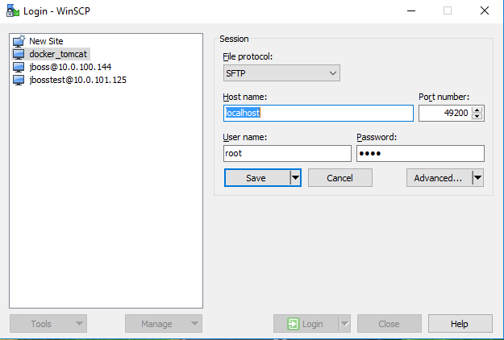

1. Navigate to /usr/local/tomcat/conf
2. Add “tomcat” user credentials to tomcat-users. To do that open tomcat-users.xml and place the following text under the <tomcat-users> tag:

<user username="tomcat" password="tomcat" roles="manager-gui,manager-script,manager-jmx,manager-status,admin-gui"/>

Save file.

1. Add apache-tomcat as maven server. Open %M2_HOME%\conf\settings.xml file. Navigate to “servers” paragraph. By default there is no server defined in maven. To define apache tomcat add the following text in “servers” area:

<servers>

<server>

<id>local_tomcat</id>

<username>tomcat</username>

<password>tomcat</password>

</server>

<servers>

Save file.

1. Open Kitematic from Docker

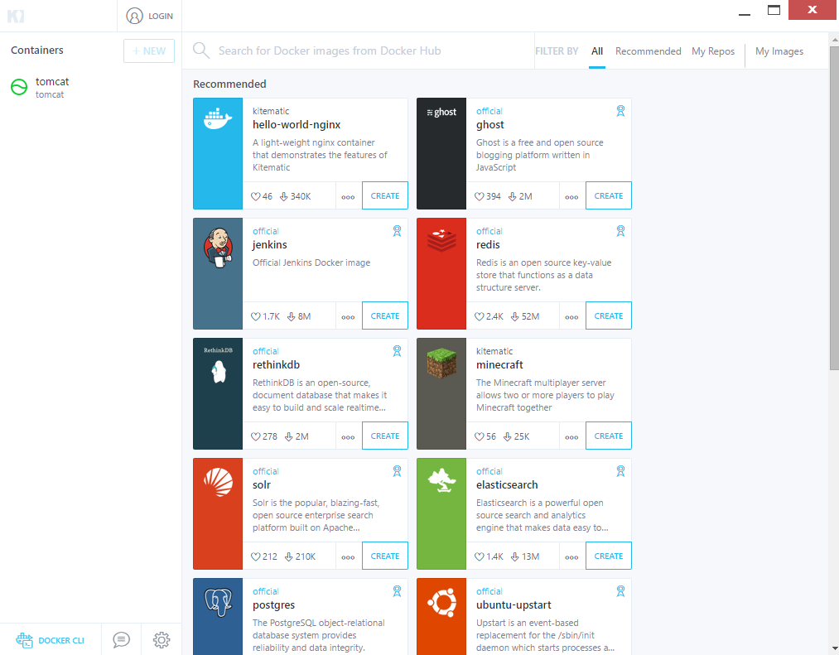

1. Open the tomcat container and see if the preview page is visible. The go to <http://docker.local:49100/manager/html> .